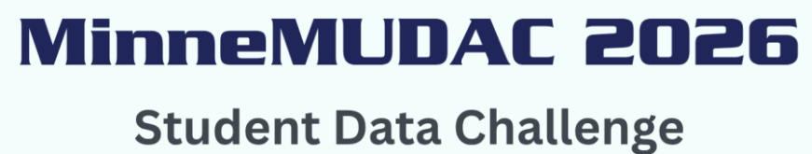

Description of Divisions
Graduate Division: For teams with advanced data management, programming, and statistical/analytic skills that support deep analytical insights, and predictive modeling. Participants in the Graduate Division are expected to propose policies that guide action. Any team with one or more graduate students will automatically be placed in the Graduate Division.
Undergraduate Division: For undergraduate teams with some experience in data management, programming, and statistical/analytic skills to support predictive modeling. Participants in the undergraduate division are expected to have a basic understanding of how findings inform policy recommendations.
Novice Division: For students early in their studies who have limited analytical experience and have little data management, data programming and statistical/analytic skills. Participants in the novice division are not expected to translate their findings into policy recommendations. Any team whose undergraduate data science program is less than two years old may participate in the Novice division.
Advisors are asked to use their best professional judgement in deciding the appropriate division for their team. Advisor, please direct any questions regarding division designations to Chris Malone or John Hogue at minnemudac@minneanalytics.org.

